Please print this page or cut out this voucher and bring it in to redeem your

Free Small Smoothie!

NuVibe Juice and Java
16105 S. Farrell Rd.
Lockport, Il. 60441
815-524-4710

This Voucher is valid for One Free Small Smoothie!

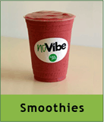

Thank you so much for your patronage!

